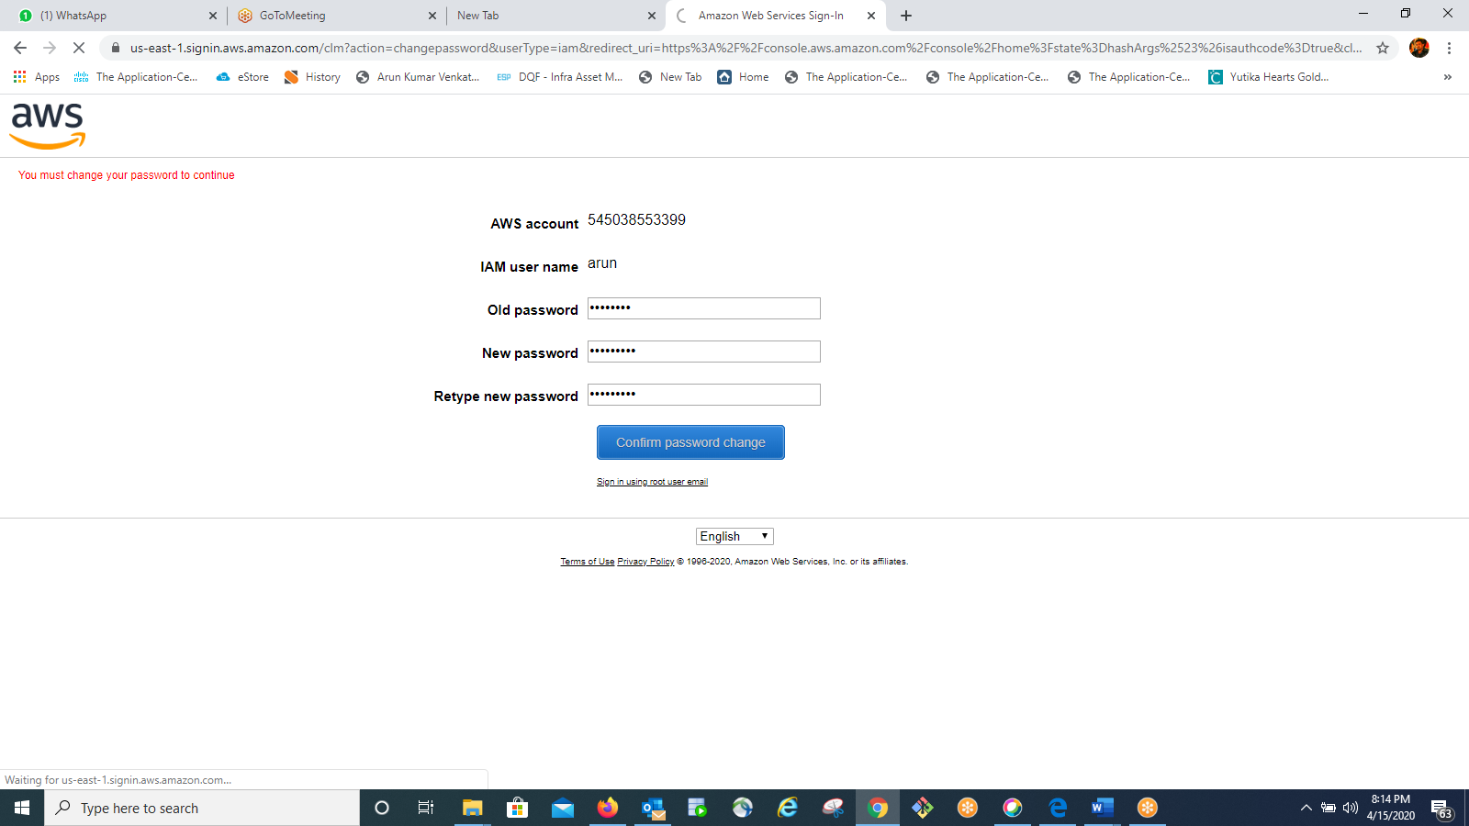

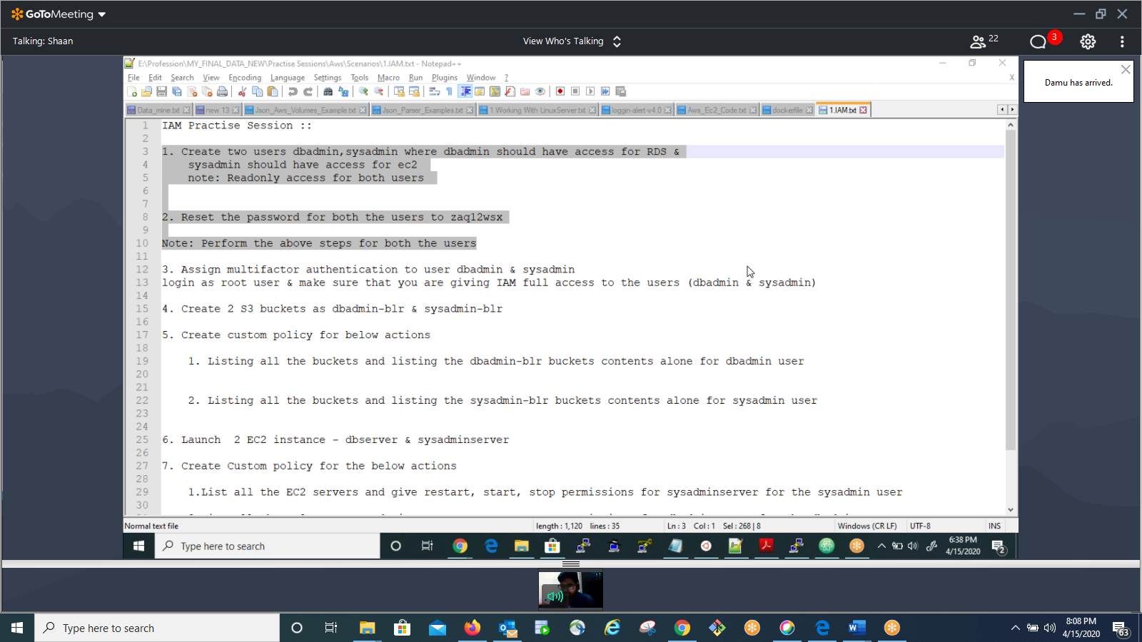

1. Create two users dbadmin,sysadmin where dbadmin should have access for RDS &  
 sysadmin should have access for ec2   
 note: Readonly access for both users   
  
  
2. Reset the password for both the users to zaq12wsx  
  
Note: Perform the above steps for both the users   
  
3. Assign multifactor authentication to user dbadmin & sysadmin  
login as root user & make sure that you are giving IAM full access to the users (dbadmin & sysadmin)  
  
4. Create 2 S3 buckets as dbadmin-blr & sysadmin-blr

5. Create custom policy for below actions  
   
 1. Listing all the buckets and listing the dbadmin-blr buckets contents alone for dbadmin user  
   
  
 2. Listing all the buckets and listing the sysadmin-blr buckets contents alone for sysadmin user  
  
  
6. Launch  2 EC2 instance - dbserver & sysadminserver  
  
7. Create Custom policy for the below actions   
  
 1.List all the EC2 servers and give restart, start, stop permissions for sysadminserver for the sysadmin user  
   
 2.List all the EC2 servers and give restart, start, stop permissions for dbadminserver for the dbadmin user